Lighting References for Studio Shots in Sailer - Insights Through Video:

Handshake lighting

Studio setup 1

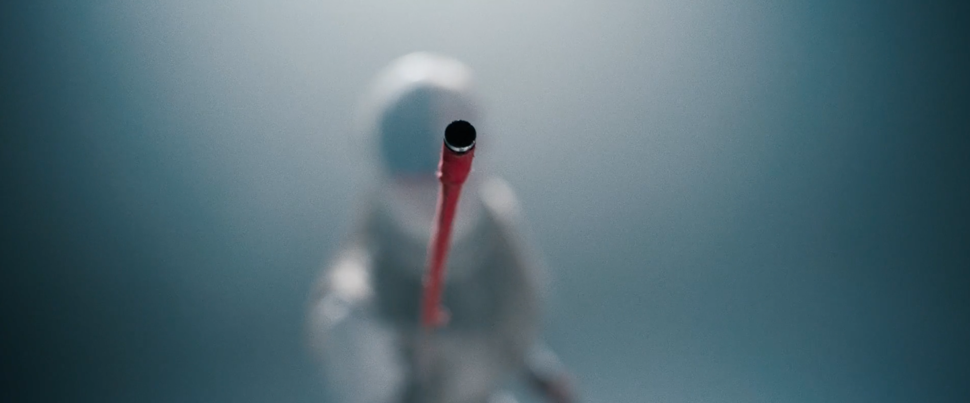
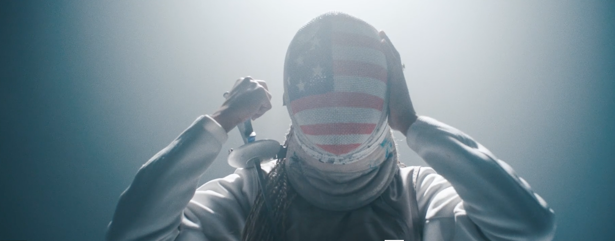

Studio setup 2
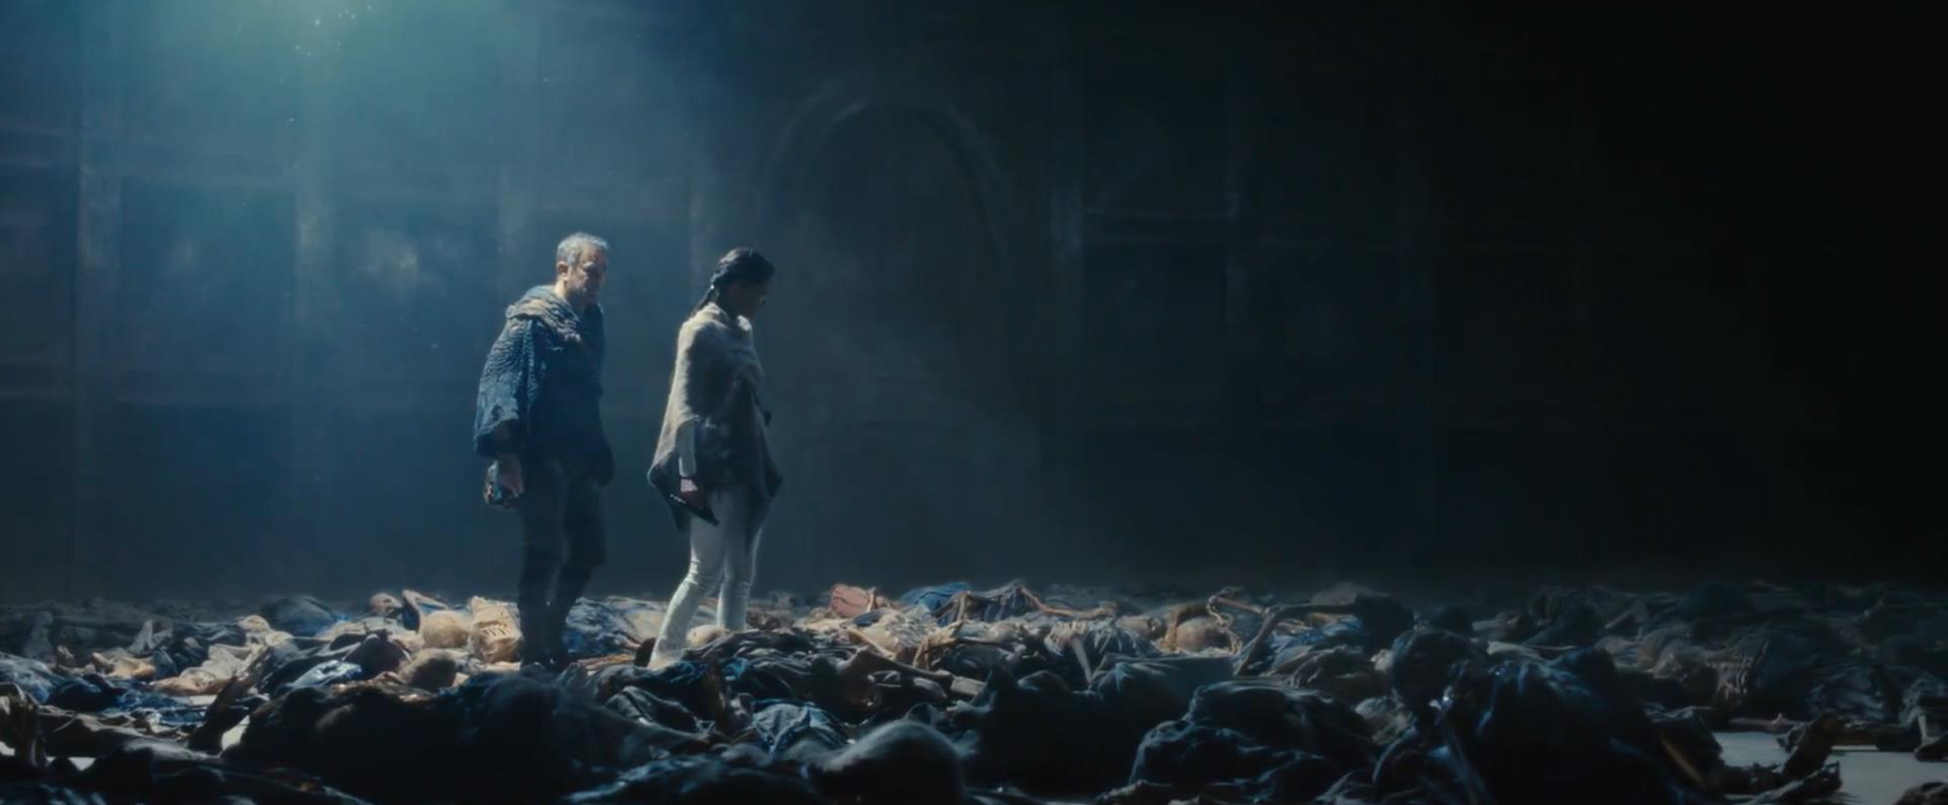

Studio setup 3 (we didn’t end up using this lighting setup in the end)

